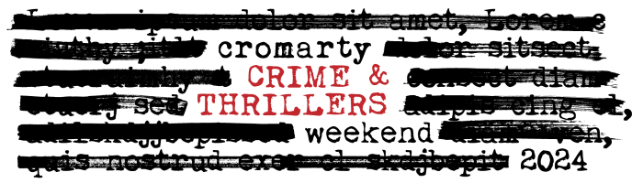
3 – 5 May 2024
Non-residential booking form

Name(s):

Tel/Mobile:

Email:

Please write the number of tickets required in the last column. If you are booking lunch please advise of allergies and/or dietary requirements here.

FRIDAY 3 May | When | Where | Price | Number of tickets
GOLD! Play | 8.00 – 10pm | Victoria Hall | £12

SATURDAY 4 May
Mark Bridgeman – Trial by Jury | 9.30 – 11am | Stables | £15
Donna Freed in conversation with Nicola White | 11:30 –12.30pm | Stables | £15
Home cooked buffet lunch | 1 – 2 pm | Old Brewery | £16.50
JD Kirk  Introducing FE Birch | 2.15 - 3.15pm | Stables | £15
Anthony Horowitz in conversation with Ian Rankin | 3.45 – 5pm | Stables | £15
Crime & Thrillers Pub Quiz (quiz entry, 4 strips raffle tickets, heads & tails) | 9pm – late | Fishertown Inn | £10

SUNDAY 5 MAY
Marsali Taylor  Introducing Sarah Smith | 10 – 11am | Stables | £15
David Alston – The Pasha Liffey Story | 11.30 – 12.30pm | Cromarty Courthouse | £15
GC Fisher – My lockdown novel | 12.45 – 1.15pm | Cromarty Courthouse | £10
Home cooked buffet lunch | 1.30– 2.30pm | Old Brewery | £16.50

The ‘Out on Parole’ Package  All author talks | £95
The ‘Doing Porridge’ Package  All talks plus Saturday & Sunday lunch | £120
TOTAL | £

I’ve made my payment of £_______________ by BACs or Cheque (delete as appropriate)

Bank of Scotland, Acc: 00911502, Sort Code: 80-06-83 (ref Crime).
Cheques payable to ‘Cromarty Arts Trust’

Now email or post this form to: info@cromartyartstrust.org.uk
The Cromarty Arts Trust, Ardyne, 19 Bank Street, Cromarty, IV11 8YE

We regret the Stables, Old Brewery & Courthouse have stairs and are not accessible for wheelchair users.
www.cromartyartstrust.org.uk

