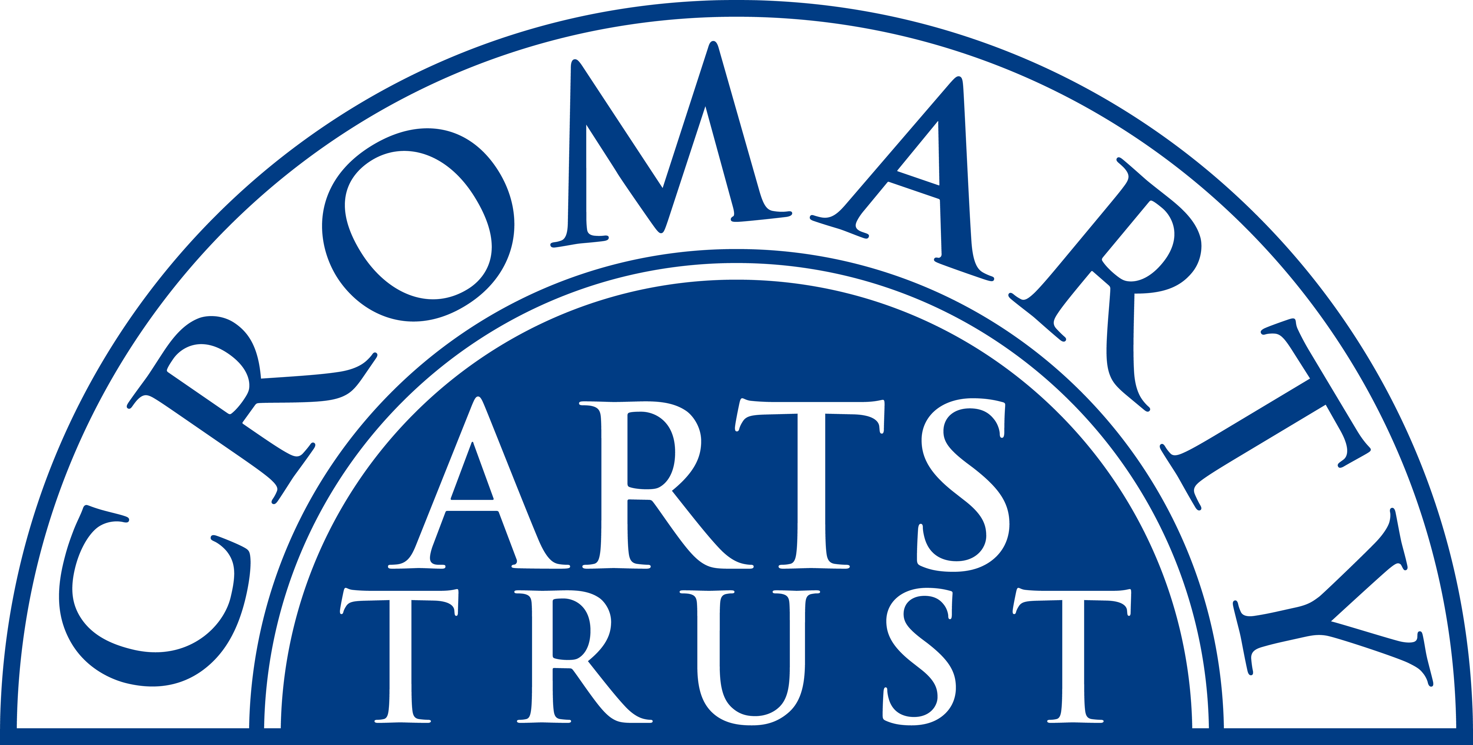
Cromarty Fiddle Weekend Booking Form
5 - 7 July 2024
Name: ________________________________________________________________________________
Address: ______________________________________________________________________________
____________________________________________________________ Postcode: ________________
Tel/Mobile: ____________________________ Email: _________________________________________
Any special dietary requirements: __________________________________________________________
Any mobility or other issues it would help us to know about: _____________________________________

Fire up your fiddle! For the first time the Cromarty Arts Trust will be hosting the Cromarty Fiddle Weekend with tutors Anna-Wendy Stevenson, Fiona MacKaskill and Zoe Livings. There are three playing levels, Elementary, Intermediate and Advanced. The workshops will be in three different venues in Cromarty, you’ll work with all three tutors and the eight workshops are designed to develop your playing skills. On Friday night there is an intimate tutor’s playing and sharing session in the loft studio after dinner.

Friday 5 July
Workshop 1 14:00 -15:30, Workshop 2 16:00 - 17:30
Welcome drinks & dinner 18:30
Tutor sharing session 20:00
Overnight accommodation at the Old Brewery

Saturday 6 July
Breakfast 08:00
Workshop 3 09:00 -10:30, Workshop 4 11:00 - 12:30
Lunch 13:00
Workshop 5 14:00 - 15.30, Workshop 6 16:00 - 17:30
Dinner 18:30
Overnight accommodation at the Old Brewery

Sunday 7 July
Breakfast 08:00
Workshop 7 09:00 -10:30, Workshop 8 11:00 -12:30
Lunch 13:00

Please indicate overleaf the events you will be attending.

Weekend Packages

Complete residential package  Two nights B&B (Fri 5 & Sat 6), two lunches, two dinners, tutor sharing session, all eight workshops | £315
Two lunches, Friday dinner, tutor sharing session, all eight workshops | £205
Two lunches, all eight workshops | £185
Discounted rate for all eight workshops | £150

Individual Bookings
Friday 5 July
Workshop 1 | 14:00 -15:30 | £20
Workshop 2 | 16:00 - 17:30 | £20

Saturday 6 July
Workshop 3 | 09:00 -10:30 | £20
Workshop 4 | 11:00 - 12:30 | £20
Lunch | 13:00 - Old Brewery | £16.50
Workshop 5 | 14:00 -15:30 | £20
Workshop 6 | 16:00 -17:300 | £20
Sunday 7 July
Workshop 7 | 09:00 -10:30 | £20
Workshop 8 | 11:00 -12:30 | £20
Lunch | 13:00 - Old Brewery | £16.50

My playing level is:
Elementary

Intermediate

Advanced

Please make sure you have ticked everything you want to attend, then post or email this form to:
Email: info@cromartyartstrust.org.uk
The Cromarty Arts Trust, Ardyne, 19 Bank Street, Cromarty, The Black Isle, IV11 8YE

Phone us on 01381 600354 if you have any queries.

I’m paying £……………………… by BACS (ref FIDDLE)
Bank of Scotland, Acc No: 00911502. Sort Code: 80-06-83

I’m paying £……………………... by cheque payable to ‘Cromarty Arts Trust’

www.cromartyartstrust.org.uk

