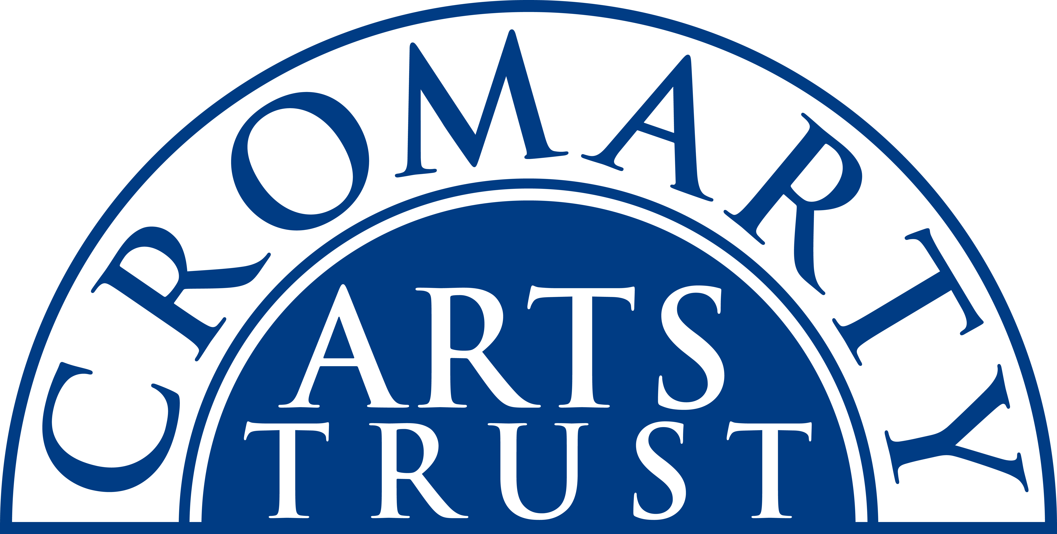
2024 BOOKING FORM

YOUR DETAILS (all information is kept in confidence)

Name of Participant
Address
Postcode

Landline & Mobile

Email
Please let us know of any mobility, dietary or other issues that would be useful for us to be aware of?

WORKSHOP / COURSE DETAILS

Name | Silver Jewellery
Date | Saturday 27th July & Sunday 28th July 10.00am-4.30pm
Total Cost | £170
25% Deposit payable on booking | £42.50
Venue | The Stables, Causeway, Cromarty IV11 8XS
Where did you hear about this course?

Please note:
- You should bring a packed lunch, and some water.
- Arrive in plenty of time, at least 15 mins before the advertised start.
- All materials will be provided.

We now require a 25% deposit to secure your place. Please tick this box once you have paid by BACs to:
Cromarty Arts Trust, Bank of Scotland, Account 00911502, Sort Code: 80 06 83 with ref July Silver

The balance for your course will be invoiced and due approximately one month prior to the start date.

Please return this completed form by email to info@cromartyartstrust.org.uk or post to Ardyne, 19 Bank St, Cromarty, IV11 8YE
We look forward to seeing you on the Silver Jewellery weekend.

