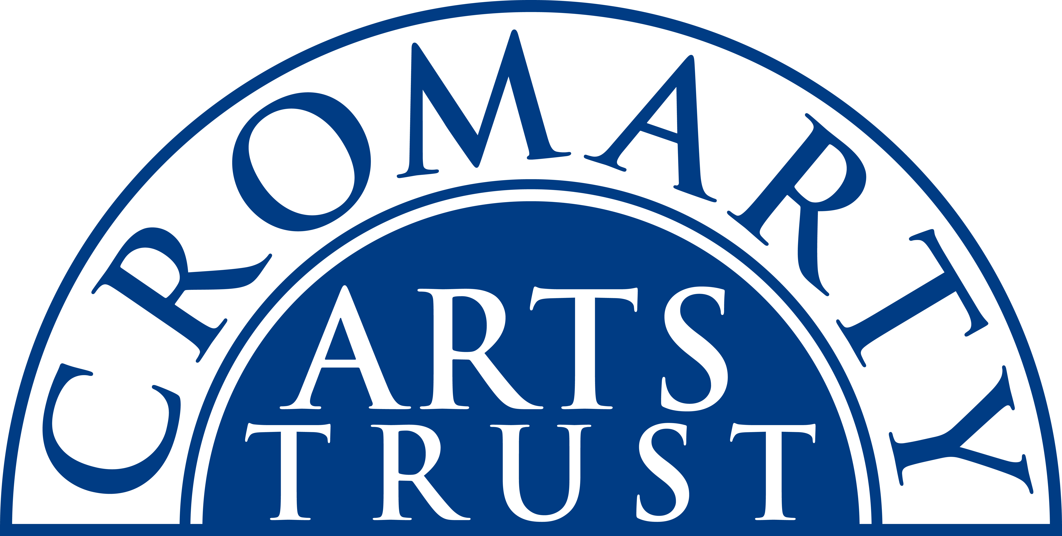
2023 BOOKING FORM

YOUR DETAILS (all information is kept in confidence)

Name of Participant
Address
Postcode
Tel
Mobile
Email
Please let us know of any mobility, dietary or other issues that you feel would be useful for us to be aware of?

WORKSHOP / COURSE DETAILS

Name | Experimental Print Making
Date | 27th May OR 28th May 2023 (please indicate which date) 10.00am-16.30pm
Total Cost | £70
25% Deposit | £17.50
Venue | The Stables, Causeway, Cromarty, IV11 8XS
Where did you hear about it?

PLEASE NOTE:
- Some workshops & courses require you to bring a packed lunch, others include a home-made lunch either at the same venue or a short walk to another venue. Check website for details.
- Some workshops & courses require you to bring equipment or materials (e.g. a sewing machine; a musical instrument; art & craft materials). Please ensure you let us know if you are unable to provide anything that you’ve been asked to as we should be able to help out.
- Please double check you know which of our two venues – The Stables and The Old Brewery – your workshop/course is taking place at.
- Please arrive at the venue in plenty of time and at least 15 mins before the advertised start.
- We regret there is no wheelchair access at The Stables and almost all courses take place up two flights of stairs. Some Old Brewery courses are also up stairs though many are on ground level.

We now require a 25% deposit to secure your place. Please pay this when you return the form – either by cheque in the post or by BACS and you can email the form. The balance for your course will be invoiced for and due approximately one month prior to the start date.

I’m paying £……………………… by BACS (ref Exp Print)
Bank of Scotland, Acc No: 00911502 / Sort Code: 80-06-83

I’m paying £……………………... by cheque payable to ‘Cromarty Arts Trust’

