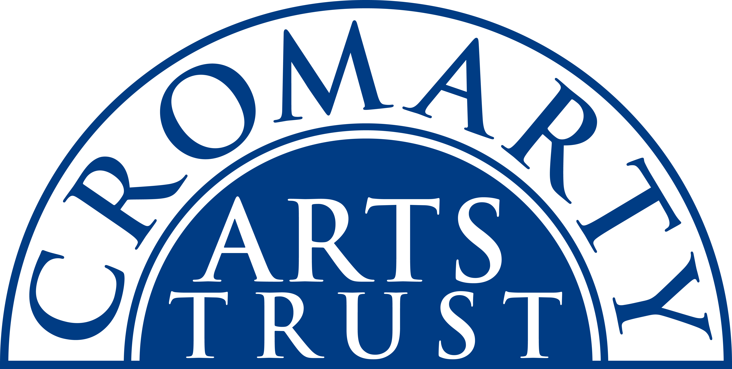
2023 BOOKING FORM

YOUR DETAILS (all information is kept in confidence)

Name of Participant
Address
Postcode
Tel
Mobile
Email
Please let us know of any mobility, dietary or other issues that you feel would be useful for us to be aware of?

WORKSHOP / COURSE DETAILS

Name | Cordage Making Workshop
Date | 16 December 2023 10.30am-15.30pm
Total Cost | £40
Venue | The Old Brewery, Burnside Place, Cromarty IV11 8XQ
Where did you hear about it?

PLEASE NOTE:
- Please bring a packed lunch.
- Please arrive at the venue in plenty of time and at least 15 mins before the advertised start.

Please pay the full fee when you return the form – either by cheque in the post or by BACS and you can email the form.

I’m paying £40 by BACS (ref Cordage)
Bank of Scotland, Acc No: 00911502 / Sort Code: 80-06-83

I’m paying £……………………... by cheque payable to ‘Cromarty Arts Trust’

