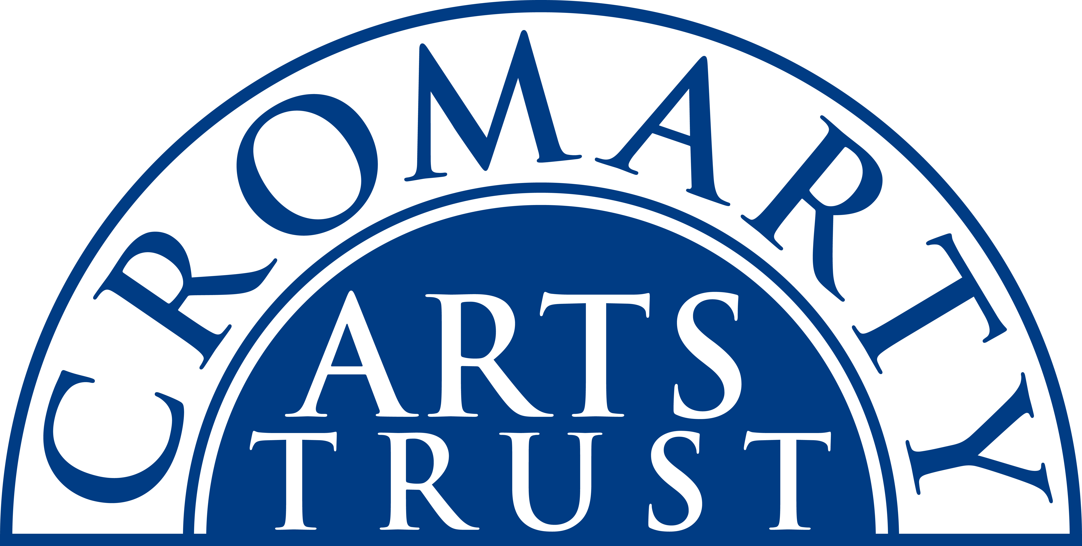
Ukulele Weekend Booking Form
Cromarty, 17th – 19th March 2023
Name: _______________________________________________________
Address: _______________________________________________________________________________
____________________________________________________________ Postcode: _________________
Tel/Mobile: ____________________________ Email: __________________________________________
Any Special Dietary Requirements: __________________________________________________________
Fire up your ukulele - Finlay Allison, presenter of the Ukulele School at Glasgow Celtic Connection returns to Cromarty with 4 new workshops for 2023! All these workshops are ’stand alone.’ If you sign up for them all you progress through a series of linked themes and develop a toolbox of techniques which you can apply to invigorate and develop your ukulele skills. The choice is yours: dip into whatever you fancy or come to them all and marvel at how your playing improves as you cover a wide range of styles and techniques. There is a Complete Beginners workshop on Saturday morning too.

Saturday 18th, 10.00 - 12.00 - £15
Workshop 1: Ukulele Intros, Outros Fills and Breaks
You know the chords…You know the song…How can you make it…better?
Good starts and finishes can improve any song immensely. And if you can add a flashy break or fill you’ll be making your music soar! In this fun workshop Finlay will show you how to make familiar songs sparkle with a few simple additions. Make your uke vibrate!

Saturday 18th, 14.00 - 16.00 - £15
Workshop 2: Useful Shapes on Ukulele
The chord shapes for G and Em are well-known-but have you tried playing them in different places on the fingerboard? Suddenly you’re playing Minor 7ths and 6ths! Finlay will help you to play chords whose names are a puzzle.

Sunday 19th, 10.00 - 12.00 - £15
Workshop 3: Matt McGinn’s songs for the Ukulele
Matt, Glasgow’s most well-known Scottish folk poet, wrote a reputed 1000 songs, many now standards, like ‘The Red Yo Yo’ and ‘Coorie Doon’. But there are many more that are ideal and fun to play on the ukulele. Finlay won’t manage the whole thousand but he’ll grab a handful of the most lively and best for you to add to your repertoire!

Sunday 19th, 14.00 - 16.00 - £15
Workshop 4: Country Jazz and Blues for the Ukulele
Learn how to slide and shuffle, damp and strum, fill and riff. A selection of different styles feature in thisworkshop helping you understand characteristics of the genres- add simple moves to make your own song arrangements whizz.

COMPLETE BEGINNERS - Saturday 18th, 10.30 - 12.00 - £10
Come and Try Ukulele for Absolute Beginners
Is there a Uke gathering dust in your house? Start your musical journey on this easy to learn instrument and join the ukulele revolution! Start your ukulele journey here. No previous experience necessary. (Ukuleles available to borrow for this workshop.)

Please indicate the events you will be attending:

Ukulele School

Complete Residential package incl. 1 x night B&B (Saturday 18th) | £155
Complete Residential package incl. 2 x nights B&B (Friday 17th & Sat 18th) | £220

Individual Bookings

Friday Night B&B Accommodation in the Old Brewery | £45.00
Friday - Two course dinner with wine + welcome drink (residents only) – 6.00pm | £30.00
Saturday Night B&B Accommodation in the Old Brewery | £45.00
Saturday – Two course dinner with wine (residents only) | £30.00
Individual Workshops | £15.00 EACH
Complete Beginners Workshop – Sat 18th | £10.00
Saturday Lunch | £15
Sunday Lunch | £15

Saturday 18th March

Breakfast | Old Brewery | 8.30am – 9.30am
Complete Beginners | Old Brewery | 10.30am – 12.00pm
Workshop 1 | Stables | 10.00am – 12.00pm
Lunch | Old Brewery | 12.30pm – 1.30pm
Workshop 2 | Stables | 2.00pm – 4.00pm
Dinner | Old Brewery | 6.00pm
Sunday 19th March

Breakfast | Old Brewery | 8.30am – 9.30am
Workshop 3 | Stables | 10.00am – 12.00pm
Lunch | Old Brewery | 12.30pm – 1.30pm
Workshop 4 | Stables | 2.00pm – 4.00pm

Please make sure you have ticked everything you want to attend and post or email this form to:
The Cromarty Arts Trust, Ardyne, 19 Bank Street, Cromarty, The Black Isle, IV11 8YE
Tel: 01381 600354 Email: info@cromartyartstrust.org.uk

I’m paying £……………………… by BACS (ref UKULELE)
Bank of Scotland, Acc No: 00911502 / Sort Code: 80-06-83

I’m paying £……………………... by cheque payable to ‘Cromarty Arts Trust’

www.cromartyartstrust.org.uk

