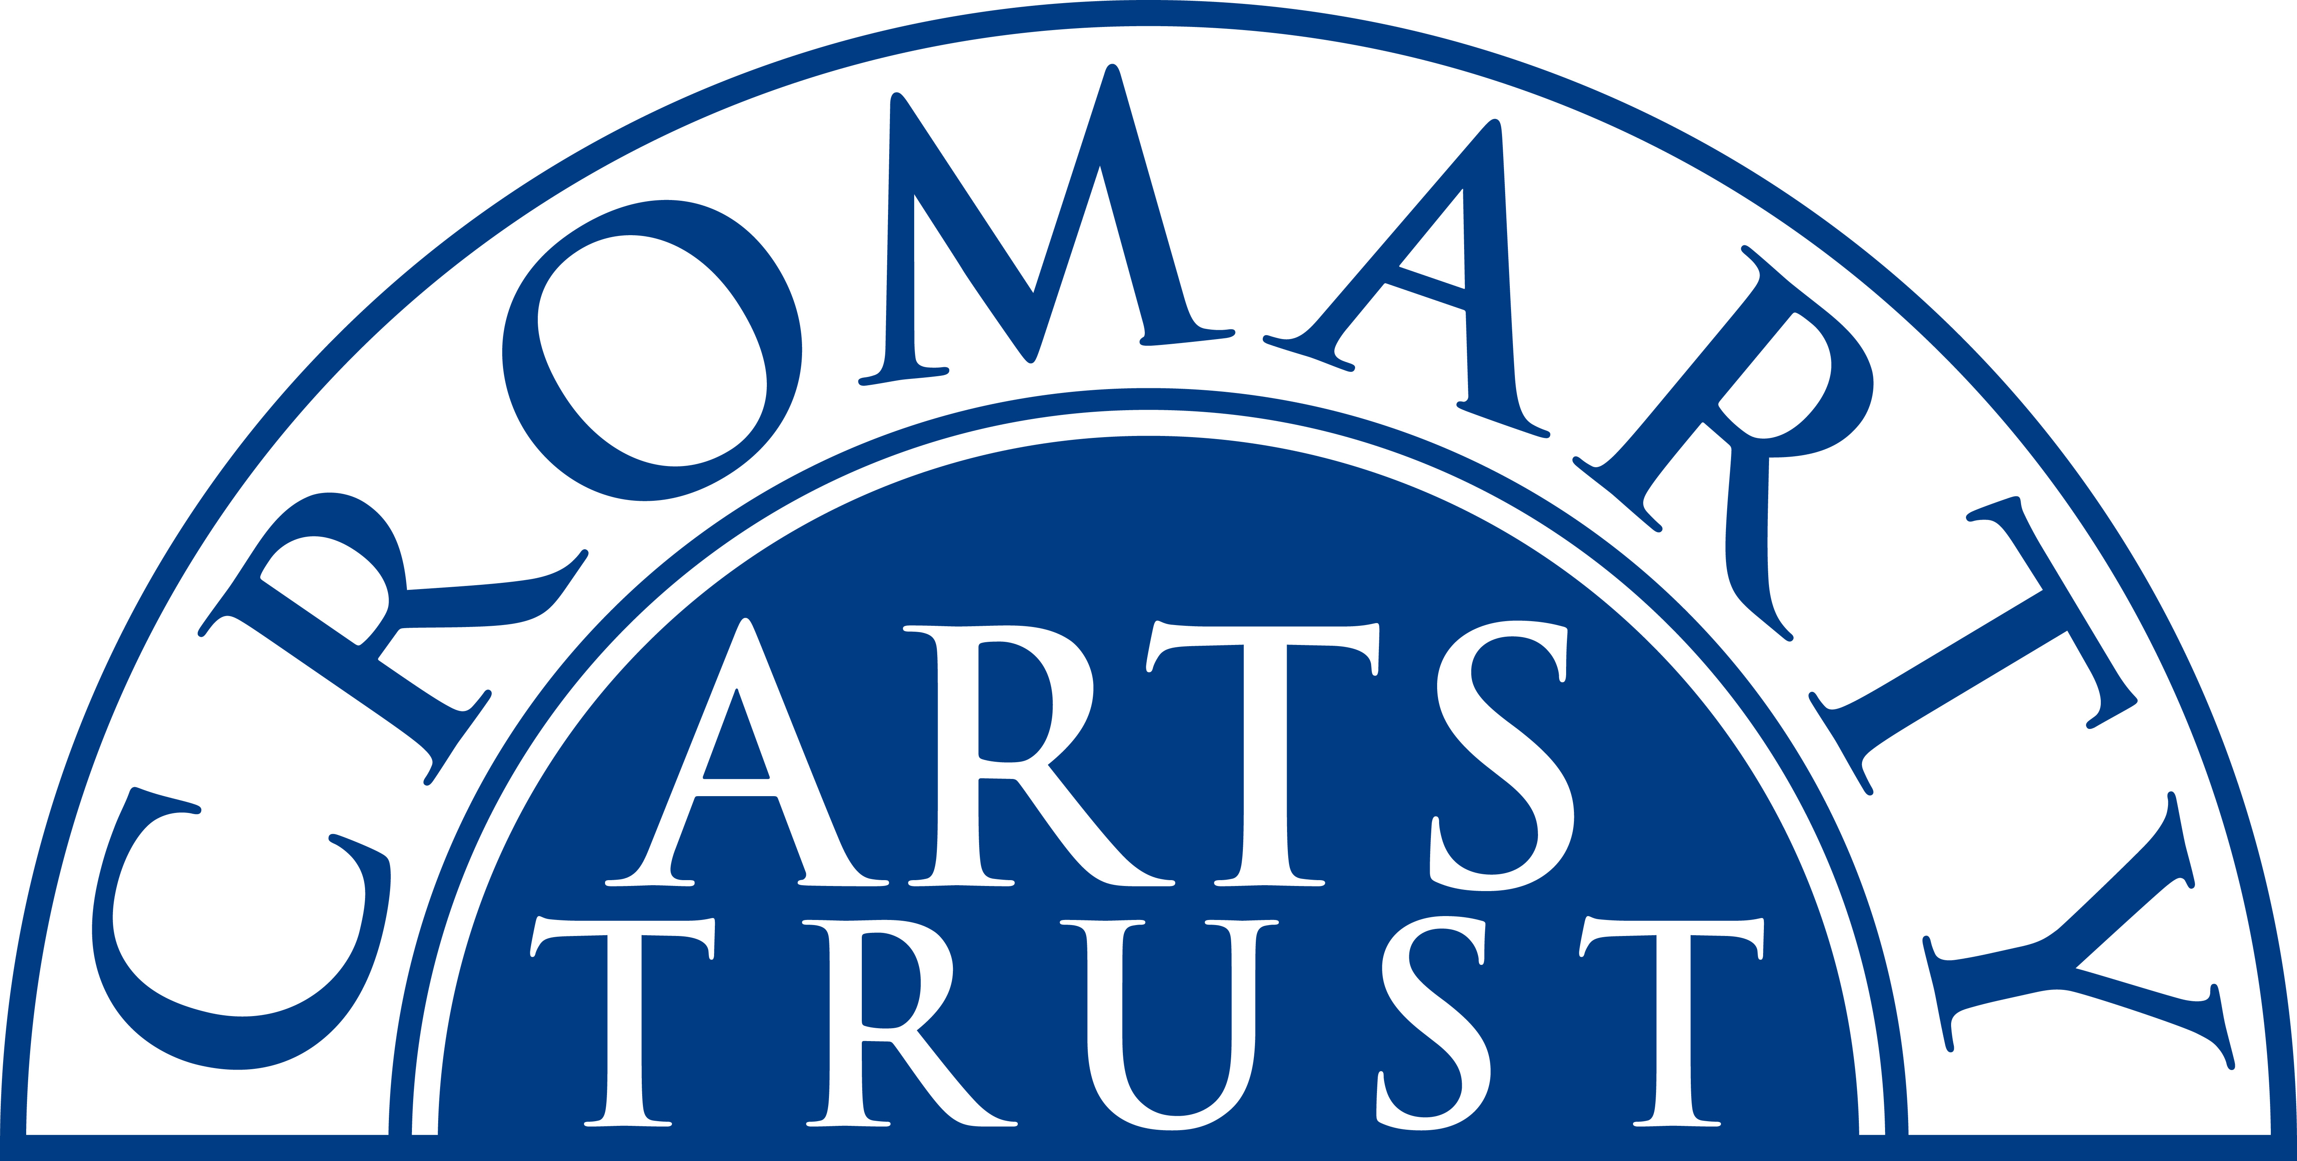
Ukulele Weekend Booking Form
Cromarty, 15th – 17th March 2024
Name: _______________________________________________________
Address: _______________________________________________________________________________
____________________________________________________________ Postcode: _________________
Tel/Mobile: ____________________________ Email: __________________________________________
Any Special Dietary Requirements: __________________________________________________________
Fire up your ukulele - Finlay Allison, presenter of the Ukulele School at Glasgow Celtic Connection returns to Cromarty with 4 new workshops for 2024! All these workshops are ’stand alone.’ If you sign up for them all you progress through a series of linked themes and develop a toolbox of techniques which you can apply to invigorate and develop your ukulele skills. The choice is yours: dip into whatever you fancy or come to them all and marvel at how your playing improves as you cover a wide range of styles and techniques. Special guest Simon Kempston will be performing at 8pm on Friday 15th in the Café.

Saturday 16th, 10.00 - 12.00 - £15
Workshop 1: Ewan MacColl Folk songs on the Ukulele
A ukulele player’s take on one of the great folk writers of the 20th century. You’ll know Ewan’s ‘Dirty Old Town’ from the playing of The Pogues. This workshop will look at some more of MacColl’s legacy in music.

Saturday 16th, 14.00 - 16.00 - £15
Workshop 2: Burt Bacharach on the Ukulele
A ukulele workshop looking at some of Burt Bacharach’s most famous songs, Raindrops Keep Fallin’ On My Head, Close to You and others made famous by dusty Springfield and the Carpenters

Sunday 17th, 10.00 - 12.00 - £15
Workshop 3: Play Country Blues on the Ukulele.
The uke is perfectly adaptable to the varied styles of American country blues. From Mississippi John Hurt to Taj Mahal and from Doc Watson to Arlo Guthrie, this entertaining workshop will give you a chance to try damping, runs and breaks, fingerpicking and more!

Sunday 17th, 14.00 - 15.30 - £10
Workshop 4: The Beatles Now and Then for Ukulele.
Now and Then tops the charts in 2023.Their greatest achievements go on and on. From oldies to the current hit. Grab your ukulele and we’ll see where it all fits together.

Please indicate the events you will be attending:

Ukulele School

Complete Residential package incl. 2 x nights B&B (Friday 15th & Saturday 16th), 2 x lunches, 2 x Dinners, all four workshops & Simon Kempston Concert. | £235
Simon Kempston Concert £14, with Two course Dinner (BYOB) -Non-Residents | £14/£35

Individual Bookings

Friday Night B&B Accommodation in the Old Brewery | £46.50
Friday - Two course dinner with wine + welcome drink (residents only) – 6.00pm | £30.00
Saturday Night B&B Accommodation in the Old Brewery | £46.50
Saturday – Two course dinner with wine (residents only) | £30.00
Individual Workshops 1, 2 & 3 | £15.00 EACH
Individual Workshop 4 | £10.00
Saturday Lunch | £16.50
Sunday Lunch | £16.50

Saturday 16th March

Breakfast | Old Brewery | 8.30am – 9.30am
Workshop 1 | Stables | 10.00am-12pm
Lunch | Old Brewery | 12.30pm-1.30pm
Workshop 2 | Stables | 2pm-4pm
Dinner | Old Brewery | 6.00pm
Jam Session | Old Brewery | 8.00pm
Sunday 17th March

Breakfast | Old Brewery | 8.30am – 9.30am
Workshop 3 | Stables | 10.00am – 12.00pm
Lunch | Old Brewery | 12.30pm – 1.30pm
Workshop 4 | Stables | 2.00pm – 3.30pm

Please make sure you have ticked everything you want to attend and post or email this form to:
The Cromarty Arts Trust, Ardyne, 19 Bank Street, Cromarty, The Black Isle, IV11 8YE
Tel: 01381 600354 Email: info@cromartyartstrust.org.uk

I’m paying £……………………… by BACS (ref UKULELE)
Bank of Scotland, Acc No: 00911502 / Sort Code: 80-06-83

I’m paying £……………………... by cheque payable to ‘Cromarty Arts Trust’

www.cromartyartstrust.org.uk

