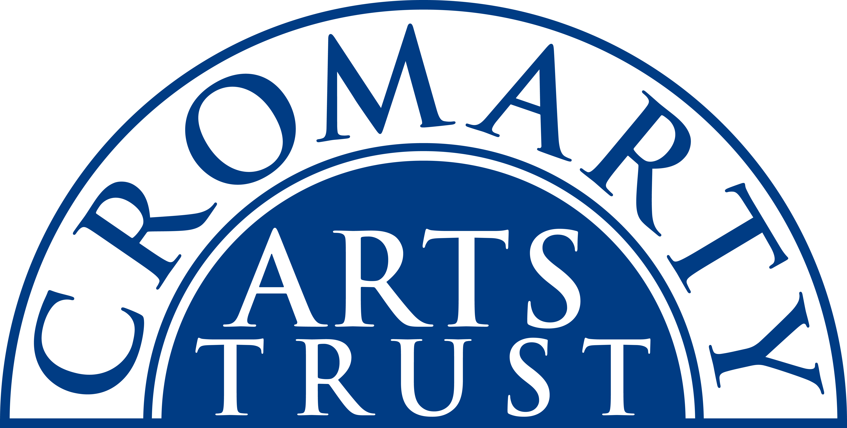
2024 BOOKING FORM

YOUR DETAILS (all information is kept in confidence)

Name of Participant
Address
Postcode

Landline & Mobile

Email
Please let us know of any mobility, dietary or other issues that would be useful for us to be aware of?

WORKSHOP / COURSE DETAILS

Name | Beginners Drawing – Four week course
Date | Mondays 22 & 29 Jan, 5 & 12 Feb 2024  7pm – 9pm
Total Cost | £65
25% Deposit payable on booking | £16.25
Venue | The Old Brewery, Burnside Place, Cromarty, IV11 8XQ
Where did you hear about this course?

Please note:
- This course is at the Old Brewery.
- Arrive in plenty of time, at least 10 mins before the advertised start.
- Sketch book and pencils will be supplied, please bring an eraser and pencil sharpener.

We now require a 25% deposit to secure your place. Please tick this box once you have paid by BACs to:
Cromarty Arts Trust, Bank of Scotland, Account 00911502, Sort Code: 80 06 83 with ref BEG DRAW

The balance for your course will be invoiced in early January.

Please return this completed form by email to info@cromartyartstrust.org.uk or post to Ardyne, 19 Bank St, Cromarty, IV11 8YE. We look forward to seeing you on the course.

