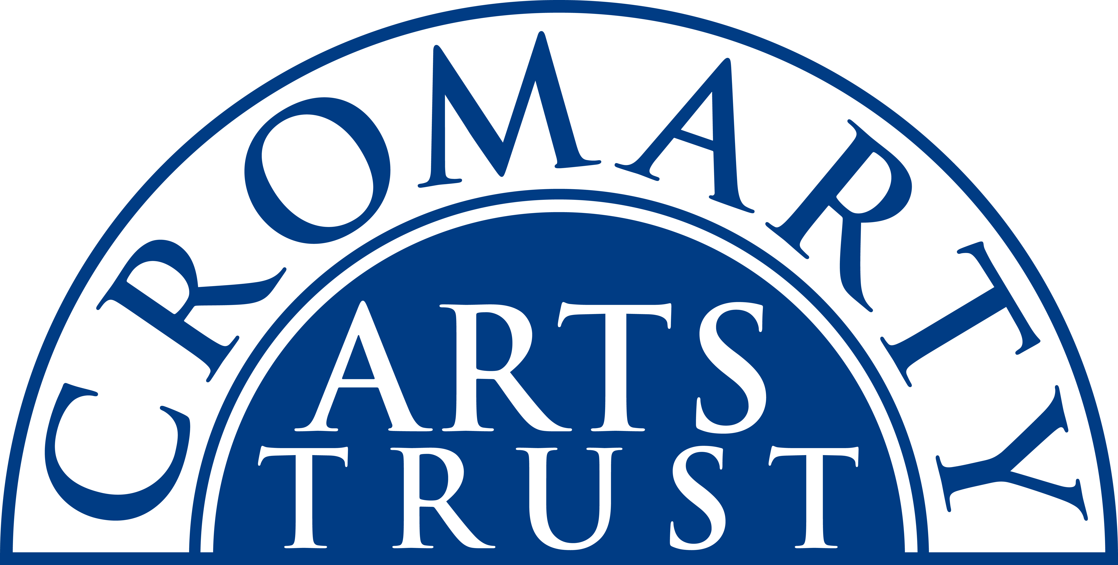
2025 BOOKING FORM

YOUR DETAILS (all information is kept in confidence)

Name of Participant
Address
Postcode

Landline & Mobile

Email
Please let us know of any mobility, dietary or other issues that would be useful for us to be aware of?

WORKSHOP / COURSE DETAILS

Name | Life Drawing Weekend.
Date | Saturday 14 & Sunday 15 June 2025 10.00am- 4.30pm
Total Cost | £160
Venue | The Stables, Causeway, Cromarty IV11 8XS
Where did you hear about this course?

Please note:
- You should bring a packed lunch both days, and some water.
- Arrive in plenty of time, at least 15 mins before the advertised start.
- You need to bring: Sketchbook, paper (A2 or larger), charcoal, compressed charcoal, pencils, masking tape, eraser, hairspray (fixative), black ink (optional) and any other drawing materials you may wish to use. If you wish to work in colour you're welcome to bring soft pastels, watercolour or acrylic/oil paint, palette, water pot.

Please tick this box once you have paid by BACs to: Cromarty Arts Trust, Bank of Scotland, Account 00911502, Sort Code: 80 06 83 with ref LIFE DRAWING

Please return this completed form by email to info@cromartyartstrust.org.uk or post to Ardyne, 19 Bank St, Cromarty, IV11 8YE. We look forward to seeing you on the Life Drawing course.

