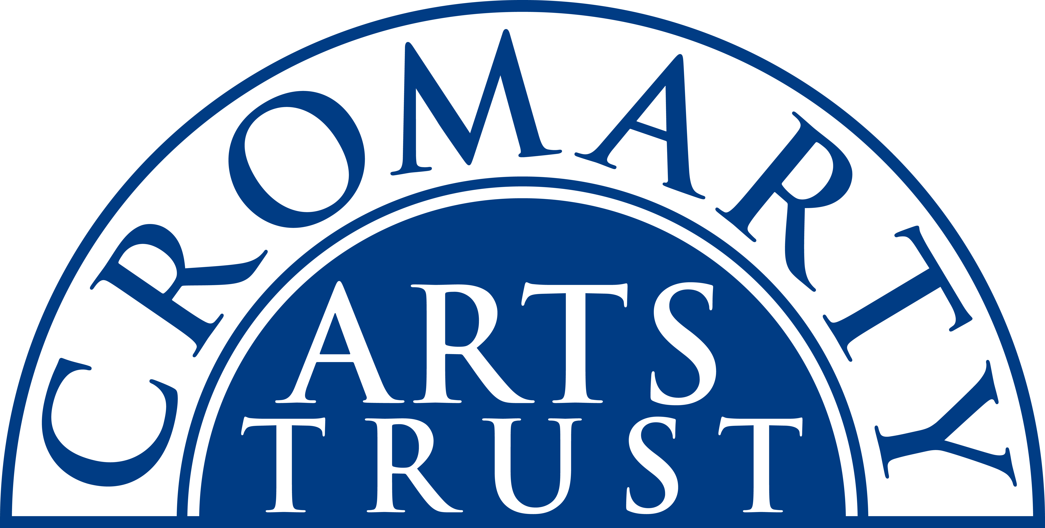
2025 BOOKING FORM

YOUR DETAILS (all information is kept in confidence)

Name of Participant
Address
Postcode

Landline & Mobile

Email
Please let us know of any mobility, dietary or other issues that would be useful for us to be aware of?

WORKSHOP / COURSE DETAILS

Name | Experimental Painting with Meg Miller
Date | Saturday 15Feb 2025 10.00am- 4.00pm
Total Cost | £50
Venue | The Stables, Causeway, Cromarty IV11 8XS
Where did you hear about this course?

Please note:
- You should bring a packed lunch.
- Arrive in plenty of time, at least 15 mins before the advertised start.

We now require payment in full to secure your place. Please tick this box once you have paid the deposit by BACs to: Cromarty Arts Trust, Bank of Scotland, Account 00911502, Sort Code: 80 06 83 with ref MEGM.

You can read our cancellation policy on our website at www.cromartyartstrust.org.uk/the-trust

Please return this completed form by email to info@cromartyartstrust.org.uk or post to Ardyne, 19 Bank St, Cromarty, IV11 8YE.

We look forward to seeing you on the course.

