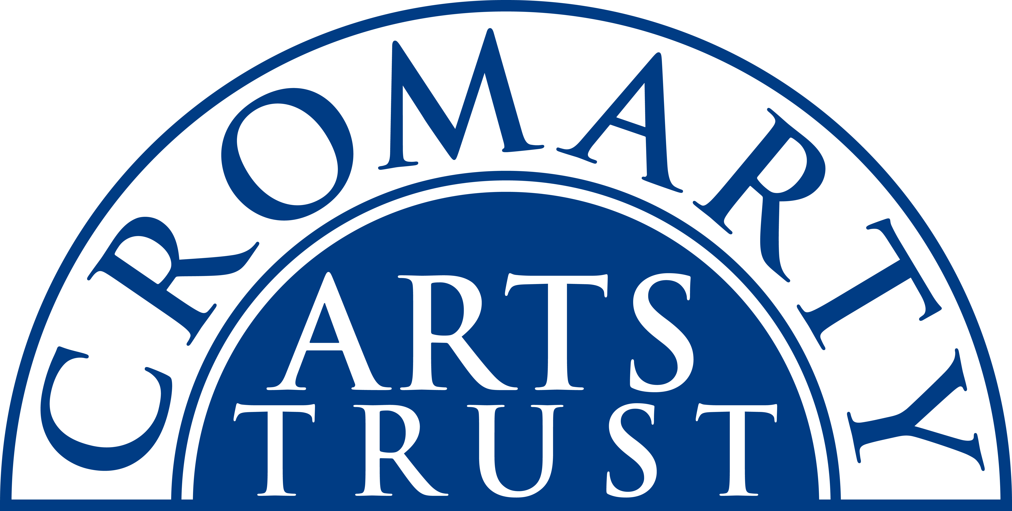
2024 BOOKING FORM

YOUR DETAILS (all information is kept in confidence)

Name of Participant
Address
Postcode

Landline & Mobile

Email
Please let us know of any mobility, dietary or other issues that would be useful for us to be aware of?

WORKSHOP / COURSE DETAILS

Name | Writing Workshop-‘Getting your writing out into the world’
Date | Friday 23rd February 2024 10.00am - 1pm
Total Cost | £35
25% Deposit payable on booking | N/A
Venue | Loft Studio, Old Brewery, Burnside Place, Cromarty IV11 8XQ
Where did you hear about this course?

Please note:
- You should bring a notepad and writing material.
- Arrive in plenty of time, at least 15 mins before the advertised start.

Please tick this box once you have paid by BACS to:
Cromarty Arts Trust, Bank of Scotland, Account 00911502, Sort Code: 80 06 83 with ref Writing

Please return this completed form by email to info@cromartyartstrust.org.uk or post to Ardyne, 19 Bank St, Cromarty, IV11 8YE
We look forward to seeing you on the Writing Workshop.

