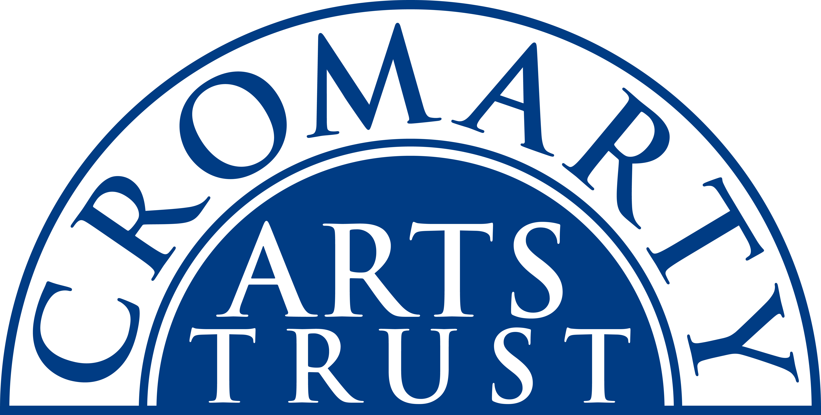
Cromarty Harp Village 15th Anniversary Year - Booking Form
19-21 September 2025

The Cromarty Harp Village is a relaxed and friendly residential weekend of music in the historic Old Brewery in the beautiful conservation Highland town of Cromarty. The workshops are run by expert tutors and players Corrina Hewat, Fiana Ní Chanoill and Gwen Màiri, suitable for all except beginner level.
Name: _______________________________________________________________________________________________
Tel/Mobile: ___________________________________________________________________________________________
Email: _______________________________________________________________________________________________
Dietary requirements: None/ Vegan/ Vegetarian /Pescatarian/Allergies: ___________________________________
Anything you’d like to tell us so we can make your stay as comfortable as possible: ________________________
______________________________________________________________________________________________________
Full Residential Single Occupancy at Old Brewery:  B&B accommodation on Fri 19 & Sat 20 Sept; Welcome drinks & dinner on Fri; Tutors concert on Fri; Dinner & massed playing session on Sat night; Lunches on Sat & Sun; 6 x workshops, Sat recap session; final get together playing session. | £350
Full Residential Two Sharing at Old Brewery: | £325
Non-Residential: includes all of the above except B&B | £220

Individual Bookings if you are NOT taking any of the packages above:

Workshop 1 Saturday 9:30 – 11:00 – includes 15 min stretching warm up movements | £20
Workshop 2 Saturday 11:30 – 12:45 | £20
Workshop 3 Saturday 14:30 – 15:45 | £20
Workshop 4 Sunday 9.30 – 11:00 – includes 15 min stretching warm up movements | £20
Workshop 5 Sunday 11:30 – 12:45 | £20
Workshop 6 Sunday 14:30 – 15:45 | £20
Saturday Lunch | £17.50
Sunday Lunch | £17.50

Please indicate your ability level, contact us if you’re not sure:
Lower Elementary | Upper Elementary | Intermediate/Advanced

IMPORTANT: Please tick here if you require us to supply you with harp:

Make sure you have ticked everything you want to attend, then post or email this form to:
The Cromarty Arts Trust, Ardyne, 19 Bank Street, Cromarty, The Black Isle, IV11 8YE
Tel: 01381 600354 Email: info@cromartyartstrust.org.uk

I’m paying £________ by bank transfer (ref HARPS). Bank of Scotland, Acc No: 00911502 Sort Code: 80-06-83
If you are having trouble with the format of this form, please give us a call.

