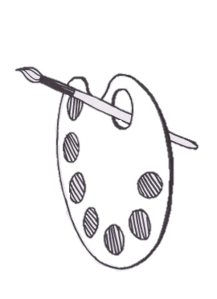**Creative Cromarty Competition 2018**

**Entry Form for Participant**

**‘Miniature World’**

If you are printing this entry form and not sending it electronically please ensure that it is filled out in BLOCK CAPITALS and is clear and easy to read.

|  |  |
| --- | --- |
| First Name: |  |
| Last Name: |  |
| Date of Birth and age: |  |
| Email address (if applicable) : |  |
| Mobile Number:  Home Number: |  |
| Type of entry:  (e.g. painting, photography, 3D model…) |  |

|  |  |
| --- | --- |
| Address:  (your address must be included in the Fortrose Academy catchment area shown on the map) |  |
| Select Category:  (cross a box) | Primary  Adult- age 11/12 and upwards |
| Background info/story on your submission:  e.g. your inspiration; subject location, reason for choosing this, feelings evoked, challenges encountered ,etc... |  |

|  |
| --- |
| Title of artwork if applicable: |
| Tick to agree to all the terms and conditions of the competition. Full terms and conditions can be found at [www.cromartyartstrust.org.uk](http://www.cromartyartstrust.org.uk) or on the information sheet. |
| Tick this box if you would like to sign up to the twice monthly Cromarty Arts Trust E-news to be updated about future events. |

Please ensure that your piece of work has your **full name** and **age** stated clearly on the back.

If you are in primary school or secondary school please also state your **year-group** on the back of your entry *e.g. primary 4 or 4th year secondary etc…*





www.cromartyartstrust.org.uk