The three brothers
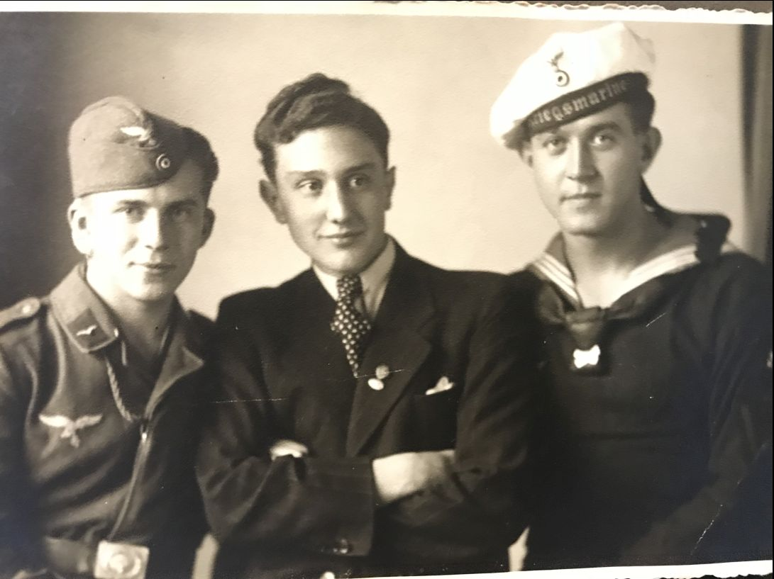

Chapter 1

In 1894 Donald was born, In 1895 Duncan was born, In 1896 David was born, all in Cromarty.
David was Not good in primary school but then developed an interest in airplanes and did very well and enjoyed the rest of school.
Both Donald and Duncan did brilliantly in school all the way through.
All the boys were tall.Their Dad worked in the rope factory, their mum worked in a shop on the Paye. They lived in a small cottage on Shore Streat. They all shared a bedroom. they fought, argued and had fun. They got along well most of the time.When it was rainy they played card game. They played outside as much as they could. They played scater, football and tig.

Chapter 2

When Donald was 18 he wanted to join the army. So he borrowed his dads bike and cycled to Inverness to the recruitment office and talked and signed paperwork. Soon he went home and told his family the good news. The next thing he knew he was practicing firing a rifle and marching at an army base a long way from home in Fort William. After three years the war started in France. In the three years he trained to be a tank driver but ended up as a sniper because he was not good at it but a very good as a sniper. He learned French at school and was promoted to Corporal and travelled to France by train and boat. When he got there he marched over to his hut . He was told at ten at night to take over the Abandoned church as a sniper spot. So he did. He went there with his men to take over the church, but when he got in it was booby trapped. But he didn't know that. So he went in and got caught in a booby trap and broke his leg. Then the Germans came and he surrendered. A few years after he was given an award for great teamwork, then he heard the bad news…

Chapter 3

When Duncan was 18 he wanted to join the navy. After one week he started training in Edinburgh. After three months he was sent to battle on the HMS hugh Miller a battleship at sea.The war happened in loads of countries like Spain, Greece, France and Italy. In battle he was on his ship next to his friend’s ship and suddenly his friend’s ship got hit by a shell and it exploded! His friend jumped off but everybody else was drowned when the ship went down. Duncan saw his friend drowning and he chucked down a rope and pulled his friend up. He was promoted to midshipman for bravery.

Chapter 4

When David was 18 he wanted to join the Air Force. After weeks of training he managed to get his pilot licence but then he suddenly found out that he wasn't allowed to fly a fighter plane because he had a weak eye. The optician said he couldn't fly because he had a weak eye so he murdered the optician. He did this because he had anger issues...David after the murder tore a sheet from the work diary so there wouldn't be a record.

Chapter 5

In 1911 a fingerprint system was created to capture people who have murdered or done other crimes.
At the opticians a policeman comes in for a test and finds the optician lying DEAD! on the floor and his diary has a page torn out where the murderer would have had his name.The policeman was clever and knew rubbing the pencil sideways would reveal what is written on the top page. He finds 4 names using the pencil rubbing trick and he uses it to find out who the murderer is by comparing their fingerprints and their name. He was the first policeman in Inverness to ever use fingerprints to capture a murderer. And he found who the murderer was and it was…DAVID!
He got caught a week later and he was sent to be hanged. The brothers found out that their brother was to be hanged one week before their big award...

Chapter 6

The three brothers meet in jail just before David was hanged in Cromarty. The brothers ran over and gave him a hug. The brothers asked why he murdered the optician. David was upset because his brother's got through into the Navy and the Army and HE murdered the optician. He was very unhappy that he did it because he suddenly lost his temper and lashed out. Suddenly a man in black took 100 steps over to David and dragged him over to the Hanging Post to be hanged. Suddenly the brother's heard a loud scream and started crying. The moral of the story is you should not get jealous of your brother's because you might end up like David.

END *****

