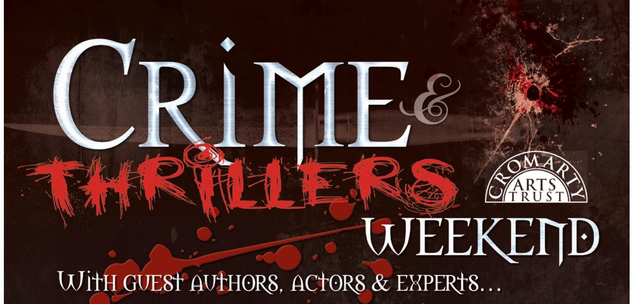

WRITING COMPETITION 2019

For the first time, the Cromarty Arts Trust has launched a Writing Competition as part of the annual Crime & Thrillers Weekend (now in its 7th successful year!).

We hope that all budding authors and perhaps even those of you brand new to writing will feel encouraged to put pen to paper and show your skills at crafting a short story with a crime and thrillers theme. The range of subjects in this genre is huge, as is the number of successful authors writing these kinds of books and scripts for TV shows, films, theatre, etc. But there is plenty of room for more talent! So why not give it a go? Here are the details:

- Two categories: Under 18 / 18+
- Genre: Crime and Thrillers
- Compulsory story title: ‘The One Hundred Steps’
- Maximum word count: Under 18: 1000 words; 18+: 2000 words
- Deadline for submissions: Midnight on 7th April 2019
- Judging: This year’s Spotlight Authors – Vee Walker, Barbara Henderson and Neil Lancaster will judge all entries
- There will be one overall winner of each category (prize: signed copies of books by this year’s four Crime & Thrillers Weekend guest authors and one runner-up in each category (winning a £15 book token each)

Please read these Terms & Conditions carefully before applying:

- The competition is open to everyone, from any area

- All work must be original and unaided and not already published in any publication, website, blog or online forum

- Entries must be written in English and double-spaced
- Only one entry per person
- The word count per entry is a maximum of 1000 words for Under 18 category and 2000 words for 18+ category. The title is not included in the word count. Please include a word count on the last page
- Entries must be submitted via email to info@cromartyartstrust.org.uk by midnight on 7th April 2019
- Late entries cannot be accepted
- Entries received on paper or via post cannot be accepted
- All work is judged anonymously. Please DO NOT include your name or age on your story but please DO complete an Entry Form and submit this with your story (the judges will not have access to form details)
- The decision of the Chair of the Judging Panel is final and no correspondence will be entered into regarding the decision
- The winners and runners-up in both categories will be notified in advance of 5th May and will gain free access to this Crime & Thrillers session. All other family members or friend wishing to attend will need to purchase tickets (see www.cromartyartstrust.org.uk/crime-and-thrillers.asp for booking form and info)
- We very much hope you will be able to attend the prize-giving ceremony that will take place as part of the final session of the Crime & Thrillers Weekend on Sunday 5th May in the Stables, Cromarty at 12.00pm. We request that winners read their submission or a section thereof at this event, or if you’d rather not, that you give permission for one of the judges or authors present to do so on your behalf.

- Prizes will be awarded by Ian Rankin

- If you are unable to attend this event, it should not deter you from entering the competition

- Cromarty Arts Trust will arrange all publicity surrounding the competition winners and press coverage should be expected (with photographs of winners together with their names and ages may be used, where parents/guardians have given their consent where appropriate)

- We reserve the right to use entries for publication or promotional purposes

- Winners will be announced on our website

WRITING COMPETITION 2019

Name

Name you write under (if different from above)
Address (incl postcode)

Tel
Email
Date of birth
Age
Category entered:
Under 18 / 18+
Name of school (if of school age)
Please state if you think you can attend prize-giving on Sunday 5th May, should you be due to receive a prize: Y or N?

Please remember NOT to include your name, age or any personal information on your story entry as they will be judged anonymously.

You will not be contacted by Cromarty Arts Trust for any purpose other than this writing competition, unless you would like to receive our fortnightly Enews, in which case please put a X here: __________

I hereby understand and agree to abide by all Terms & Conditions.

Signed: ______________________________________ Date: ______________________

FOR OFFICIAL USE ONLY:
Date entry received
Number allocated

