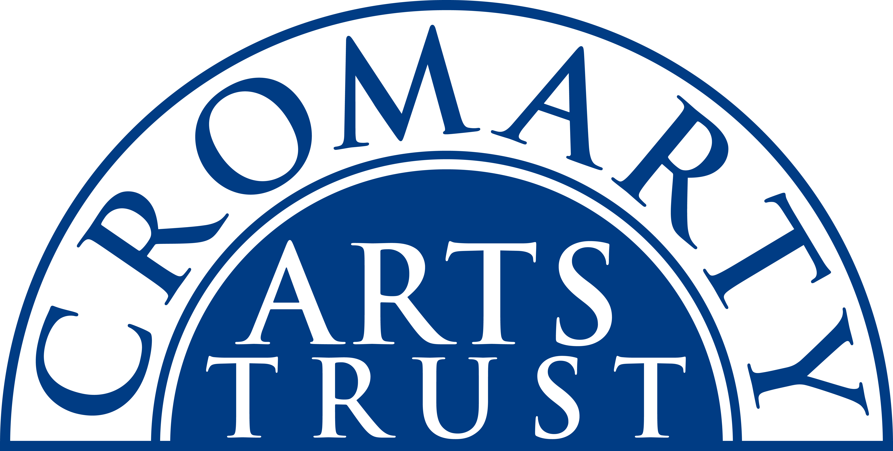
Cromarty Harp Village - Application Form
September 20th – 22nd 2019
Name: _______________________________________________________
Address: _______________________________________________________________________________
____________________________________________________________ Postcode: _________________
Tel/Mobile: ____________________________ Email: __________________________________________
Any special dietary requirements and/or other issues it would be useful for us to know about: ______________________________________________________________________________
The Cromarty Harp Village is a two-day residential weekend of music in the beautiful surroundings of the Old Brewery in the vibrant, coastal Highland town of Cromarty. There are workshops all day on Saturday and Sunday run by Corrina Hewat, Rachel Newton, Mary Macmaster and Isbel Pendlebury suitable for elementary, intermediate & advanced levels. There will be a Tutors’ Concert on the Friday evening plus an all-inclusive ‘Megaharp’ Session in the Loft Studio of the Old Brewery – sea views and wonderful acoustics – offers a relaxed opportunity for participants to get to know each other and play together or just sit back and enjoy the music.

Please indicate the events you will be attending:

Full Residential package: B&B accommodation on Friday 20 & Saturday 21 Sept at the Old Brewery; welcome drink & dinner on Fri; Tutors’ Concert on Fri; dinner and Megaharp session on Sat; lunches on Sat & Sun; 4 x workshops (2 on Sat; 2 on Sun). | £220
Non-Residential package: includes all of the above except B&B | £150

Individual Bookings

Workshop 1: Saturday, 10.00am – 12.00pm | £20
Workshop 2: Saturday, 2.00pm – 4.00pm | £20
Workshop 3: Sunday, 10.00am – 12.00pm | £20
Workshop 4: Sunday, 1.30pm – 3.30pm | £20
Friday Welcome Drinks & Dinner (BYOB): 6.00pm | £18
Friday Tutors’ Concert in Café: 8.00pm | £10
Saturday Lunch: 12.30pm – 1.30pm | £12
Saturday Dinner (BYOB): 6.00pm & Megaharp Session: 8.00pm | £22
Sunday Lunch: 12.15pm – 1.15pm | £12

Please indicate your ability level (contact us if you’re not sure):

Lower Elementary | Upper Elementary | Intermediate | Advanced
Please make sure you have ticked everything you want to attend and post or email this form to:
The Cromarty Arts Trust, Ardyne, 19 Bank Street, Cromarty, The Black Isle, IV11 8YE
Tel: 01381 600354 Email: info@cromartyartstrust.org.uk
I’m paying £…………… by BACS (ref HARPS). Bank of Scotland, Acc No: 00911502 / Sort Code: 80-06-83
I’m paying £……………. by cheque payable to ‘Cromarty Arts Trust’

