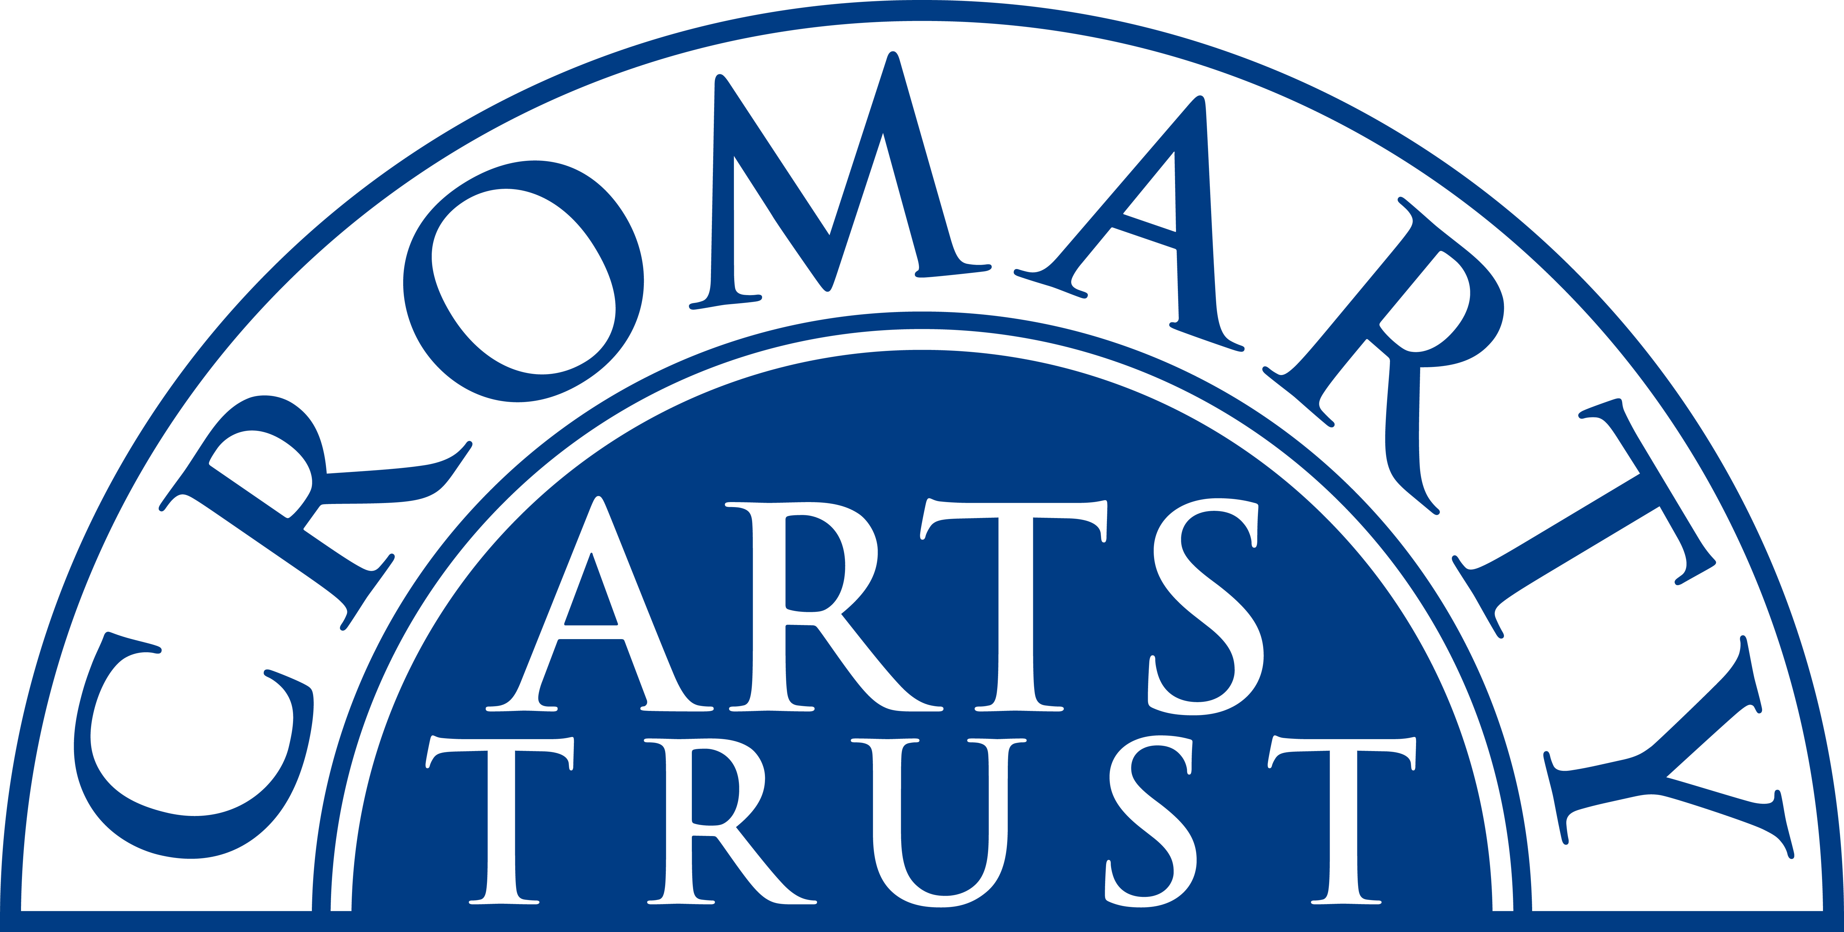
CROMARTY CHRISTMAS MARKET 2025
APPLICATION FORM

Dates:
- Saturday 8 Nov – 10 am – 4pm (mulled wine/mice pies from 2 – 4pm)
- Sunday 9 Nov – 10 am – 4pm

Cost:
A table/space is £60 for the duration. Payment is due in full once your place has been allocated (30 Aug 2025)

Location:
The Old Brewery, Cromarty.

Your details

Name of Participant/s
Company/Trading Name
Address
Telephone – mobile & landline
Email

Website

Facebook and Instagram names | Please like and follow our Facebook and Instagram pages – this helps us tag you.
Please describe a bit about yourself and what you will be selling.
Do you sell your work in other places? If so where?
Very important. Please send at least two good quality individual photographs of your products. You can include a photo of your stall/table at other fairs but I can’t use this for promotion. Please don’t send composite photos.

We have more applications for stalls than ever before and so are only taking bookings that can commit to coming for both days. We keep our markets fresh and varied for our visitors so please don’t be offended if you are not chosen this time. You’ll be notified if you are successful by the end of August 2025.

