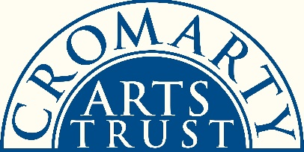
STUDENT RESIDENCY PRIZE 2021
APPLICATION FORM

Please complete the following and submit with the rest of your application.
Personal Details:
Name
Address

Tel
Email
Website (if applicable)
Date of birth

Education:
Name of art school / college / establishment attended (please note, this has to be in Scotland)
Name of course

Academic attainment level achieved (e.g. BA Hons, Diploma, etc)
Month & year of graduation

Any further information, such as details of your studies, what you have done since graduating, what you hope to do in the future, should be included as a C.V. or separate document. This is not compulsory.
Please let us know how you heard about the Cromarty Arts Trust Student Residency Prize:

To Apply:
Please ensure your application includes the following:
- This form, completed
- Your statement (max 1000 words): what you might explore and develop during a residency with the Cromarty Arts Trust – themes, ideas, areas of interest; how you might go about achieving these; what your end presentation / exhibition / talk / workshop might entail; why you wish to be considered (i.e. your chance to sell yourself!).
Cromarty is a vibrant, tight-knit community at the end of a Highland peninsula - we are particularly keen to see evidence that you have researched and understood a little about the town and where your artistic ideas might fit into its framework. Applicants should visit our website to see what direction previous residency winners have taken.

- Up to a maximum of FIVE items of your work as examples to be considered: photographs, written pieces, sketches, etc. If you have hard copy items you wish to include, this is acceptable if you post them to us with a stamped-addressed envelope for their safe return.

- Two relevant references. These do not need to be longer than one paragraph each.

Our preference is for all of the above elements to be emailed to info@cromartyartstrust.org.uk, alternatively you can send us a link to an internet-based computer file transfer service such as Dropbox, WeTransfer, etc.

Applications should be made directly to the Cromarty Arts Trust no later than 5pm, Friday 2nd July 2021.
We will aim to announce a winner by mid-August.
Please note – the residency will take place on EITHER 28th Sept – 28th October OR 1st – 30th November 2021. The winner can choose which of these options they prefer. If you know you are unable to attend at either of these times, please do NOT enter the competition as this year our dates are not as flexible as some previous years.

