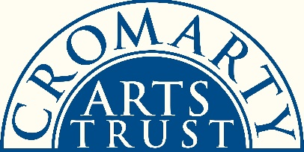
STUDENT RESIDENCY PRIZE 2019
APPLICATION FORM

Please complete the following and submit with the rest of your application.
Personal Details:
Name
Address

Tel
Email
Website (if applicable)
Date of birth
Age

Education:
Name of art school / college / establishment attended (please note, this has to be in Scotland)
Name of course

Academic attainment level achieved (e.g. BA Hons, Diploma, etc)
Month & year of graduation

Any further information, such as details of your studies, what you have done since graduating, what you hope to do in the future, should be included as a C.V. or separate document. This is not compulsory.
Please let us know how you heard about the Cromarty Arts Trust Student Residency Prize:

To Apply:
Please ensure your application includes the following:
- This form, completed
- Your statement (max 1000 words): what you might explore and develop during a residency with the Cromarty Arts Trust – themes, ideas, areas of interest; how you might go about achieving these; what your end presentation / exhibition / talk / workshop might entail; why you wish to be considered (i.e. your chance to sell yourself!).
Cromarty is a vibrant, tight-knit community at the end of a Highland peninsula - we are particularly keen to see evidence that you have researched and understood a little about the town and where your artistic ideas might fit into its framework. Applicants should visit our website to see what direction previous residency winners have taken.

- Up to a maximum of FIVE items of your work as examples to be considered: photographs, written pieces, sketches, etc. If you have hard copy items you wish to include, this is acceptable if you post them to us with a stamped-addressed envelope for their safe return.

- Two relevant references. These do not need to be longer than one paragraph each.

Our preference is for all of the above elements to be emailed to info@cromartyartstrust.org.uk.
You can also put everything on a clearly labelled USB stick and mail that to us at: Student Residency Prize, Cromarty Arts Trust, Ardyne, 19 Bank St, Cromarty, Ross-Shire, IV11 8XS. Sticks can be returned at a later date if need be.

Applications should be made directly to the Cromarty Arts Trust no later than 5pm, Wednesday 12th June 2019.

